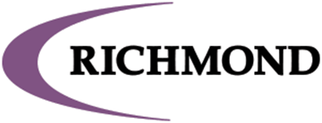

**2020-21 Annual District Goals**

**Mission Statement**

Preparing Today’s Child For A Successful Tomorrow

**Richmond School Vision Statement**

Through the partnerships with families, community members, students, and fellow educators, The Richmond School District will be recognized for its academic excellence by developing the whole student to become a life-long learner.

The district goals are based on priorities identified in five categories (Student Learning, Assessment, College and Career Readiness, Community, and Fiscal Responsibility) that align with the district’s Strategic Plan and address budgetary, learning, leadership, and communication needs:

**Goal #1 Richmond will improve from 66.8% proficient to 70.1% proficient, as measured by the Forward Math Exam (grades 3-8) by the end of the 2020-21 school year.**

Strategic Plan Focus - Math

**Goal #2 Richmond will improve from 69.7% proficient to 71.2% proficient, as measured by the Forward ELA Exam (grades 3-8) by the end of the 2020-21 school year.**   
Strategic Plan Focus - Literacy

**Goal #3 Create staffing conditions to retain and attract high quality staff by achieving 4/4 Personnel Tasks**

Strategic Plan Focus - Personnel

**Goal #4 Maintain facility and infrastructure to support student learning and safety**

Strategic Plan Focus – Facilities Infrastructure

**Goal #5 Increase communication to enhance community engagement and outreach**

Strategic Plan Focus – Community Engagement

**Goal #6 Maintain financial health and focus financial resources on long-term academic achievement**

Strategic Plan Focus - Fiscal Responsibility

\**updates regarding performance around the District goals will be provided to the Board of Education after the end of each trimester*